Week-2

Learning Module - ReactJS:

* **JSX**
* **Component and JSX**
* **Component lifecycle and Props.**
* **Router**

Assignment : Notice board system where 3 panels 1) Input Panel 2) Admin Panel for review 3)Public pane for display.

File Structure:

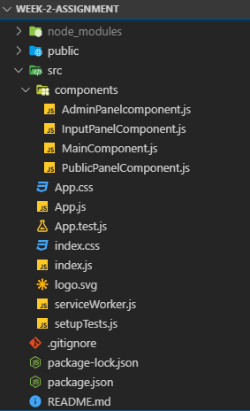

NOTICE BOARD SYSTEM:

* This is a simple notice board system buit in react. In this notice board system First We have add new notice and than admin will review the notice and if there is any changes required in notice than admin will send back notice with feedback.
* If no changes required than notice will publish to the public panel.

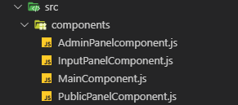

MainComponent.js:

* It is basically a root component. Also store the data for the system and pass as a props to the component. Control the route of the system.
* Here main component store the data of notice and send it to the admin panel for review.
* If notice is not valid than admin give feedback and reject the notice. That feedback will display in the inputaComponent and after doing modification user can submit updated notice.
* If notice is valid than notice will display to the public.

this.state = {

title: "",

description: "",

valid: false,

feedback: ""

};

<Switch>

<Route path="/inputPanel" render={(props) => (

<InputPanel {...props}

title={this.state.title}

description={this.state.description}

valid={this.state.valid}

feedback={this.state.feedback}

onClick={(title, desc) => this.onSubmitData(title, desc)} />

<Route path="/adminPanel" render={(props) =>

(<AdminPanel ... /> )} />

<Route path="/publicPanel" render={(props) =>

(<PublicPanel ... />)} />

<Redirect to="/inputPanel" />

)} />

</Switch>

InputPanelComponent.js:

It is contain the input fields where we can enter the data of the notice and after submit data it will go for admin review.

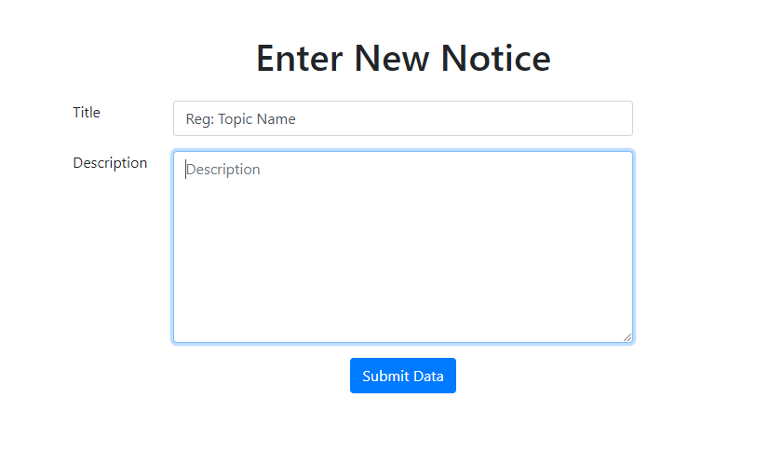

AdminPanelComponent.js:

Here admin review the notice if there is no change require than notice will pubish but if there is any change require than admin can send back notice with feedback.

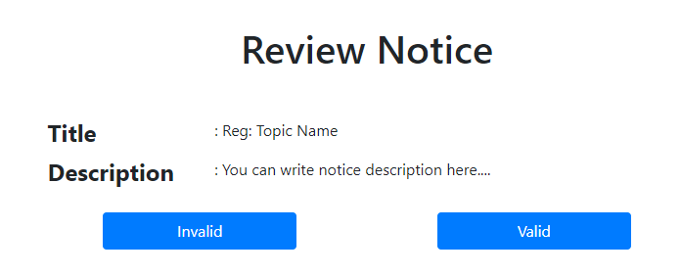

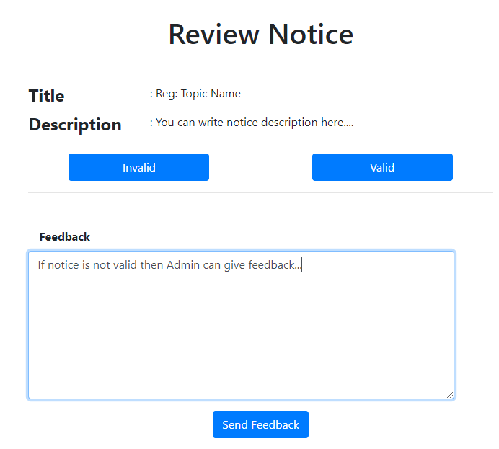

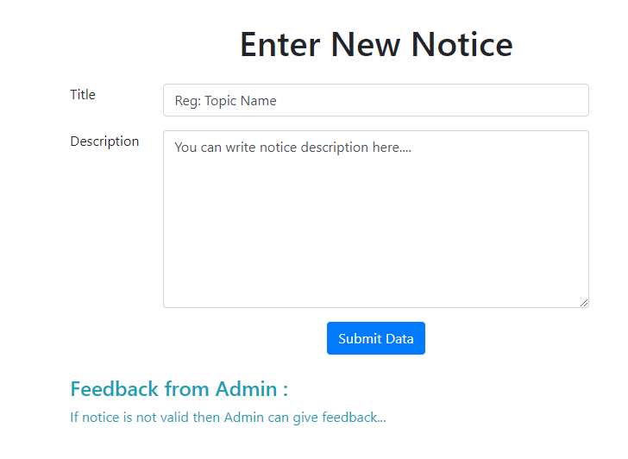

PubicPanelComponent.js:

After successfull review of the notice it will display here.

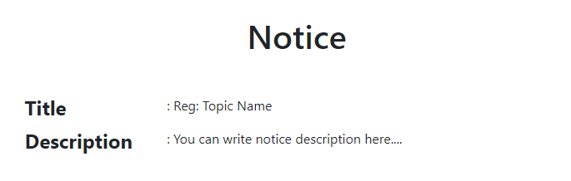

Learning Outcome:

In this week I have learn about react, components in react, routes in react, etc. I also learn about How to make a single page application in react, etc.